Lactobacillus iners, Strain LEAF 3008A-a

Catalog No. HM-708

Product Description:
Lactobacillus iners, strain LEAF 3008A-a was isolated from a human vagina. HM-708 was produced by inoculation of BEI Resources seed lot 61881796 into Lactobacillus MRS broth and incubated for 3 days at 37°C in an anaerobic atmosphere (< 5% O₂; Remel™ Pack-Anaero™). The material from the initial growth was used to inoculate Tryptic Soy agar with 5% defibrinated sheep blood kolles, which were grown for 3 days at 37°C in an anaerobic atmosphere to produce this lot. Quality control testing was completed under propagation conditions unless otherwise noted.

Note: Quality control of HMP material is only performed to demonstrate that the material distributed by BEI Resources is identical to the deposited material. It should not be considered a complete characterization of the deposited organism.

Lot: 70061790 Manufacturing Date: 13JUL2023

TEST | SPECIFICATIONS | RESULTS
Phenotypic Analysis
Cellular morphology | Gram-positive rods | Gram-positive rods
Colony morphology | Report results | Circular, slightly peaked, entire, smooth and translucent (Figure 1)
Motility (wet mount) | Report results | Non-motile
Genotypic Analysis  Sequencing of 16S ribosomal RNA gene  (~ 1520 base pairs) | ≥ 99% sequence identity to L. iners, strain LEAF 3008A-a  (GenBank: AEKK01000019.1) | 99.9% sequence identity to L. iners, strain LEAF 3008A-a  (GenBank: AEKK01000019.1)
Purity (post-freeze)
Anaerobic  7 days at 37°C on Tryptic Soy agar with 5% defibrinated sheep blood | Report results | Growth consistent with expected colony morphology
Aerobic with 5% CO₂  7 days at 37°C on Tryptic Soy agar with 5% defibrinated sheep blood | Report results | Growth consistent with expected colony morphology
Viability (post-freeze) | Growth | Growth

Figure 1: Colony Morphology

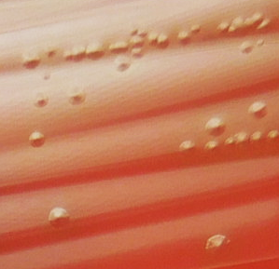

/Sonia Bjorum Brower/
Sonia Bjorum Brower 06 SEP 2023
Technical Manager or designee, ATCC Federal Solutions

ATCC®, on behalf of BEI Resources, hereby represents and warrants that the material provided under this certificate has been subjected to the tests and procedures specified and that the results described, along with any other data provided in this certificate, are true and accurate to the best of ATCC®'s knowledge.

ATCC® is a trademark of the American Type Culture Collection.


You are authorized to use this product for research use only. It is not intended for human use.

