Cat # | Reagent Name | Specificity
36 | Anti-HIV-1 IIIB gp120 Polyclonal (PB1 IIIB) | IIIB gp120 (aa 295-474)
38 | Anti-HIV-1 IIIB gp120 Polyclonal (PB1 IIIB-Sub 7) | IIIB gp120 (aa 350-455)
40 | Anti-HIV-1 IIIB gp120 Polyclonal (PB1 IIIB-Sub 2) | IIIB gp120 (aa 295-404)
41 | Anti-HIV-1 MN/RF gp120 Polyclonal (PB1 MN/RF) | MN and RF gp 120 (aa 295-474)
43 | Anti-HIV-1 SC gp120 Polyclonal (PB1 SC) | SC gp120 (aa 295-474)
45 | Anti-HIV-1 RF gp120 Polyclonal (PB1 RF) | RF gp120 (aa 295-474)
46 | Anti-HIV-1 IIIB gp120 Polyclonal (PB1 IIIB-Sub 2-CN1) | IIIB gp120 (aa 295-333)
47 | Anti-HIV-1 MN gp120 Polyclonal (PB1 MN) | MN gp120 (aa 295-474)
51 | Anti-HIV-1 IIIB/RF gp160 Polyclonal (HT3-HT7) | IIIB and RF gp160; reacts with both proteins
56 | Anti-HIV-1 WMJ gp120 Polyclonal (PB1 WMJ) | WMJ gp120 (aa 295-474)
57 | Anti-HIV-1 IIIB gp120 Polyclonal (PB1 IIIB-Sub 6) | IIIB gp120 (aa 350-474)
188 | Anti-HIV-1 IIIB gp160 Polyclonal (HT3) | IIIB gp160 (entire sequence)
189 | Anti-HIV-1 RF gp160 Polyclonal (HT7) | RF gp 160 (entire sequence)
190 | Anti-HIV-1 IIIB-RF gp120 Polyclonal (HT6) | IIIB gp 160 containing substituted RF PB1 domain (aa 295-474); reacts with both proteins
191 | Anti-HIV-1 IIIB/RF gp160 Polyclonal (gp160 AS) | IIIB and RF gp160 ; reacts with both proteins

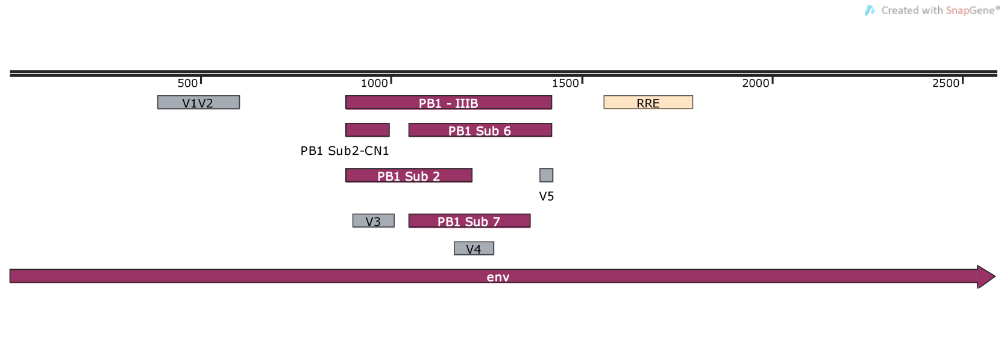
Map of HIV-1 IIIB Env with variable loops and PB1 sections denoted:

